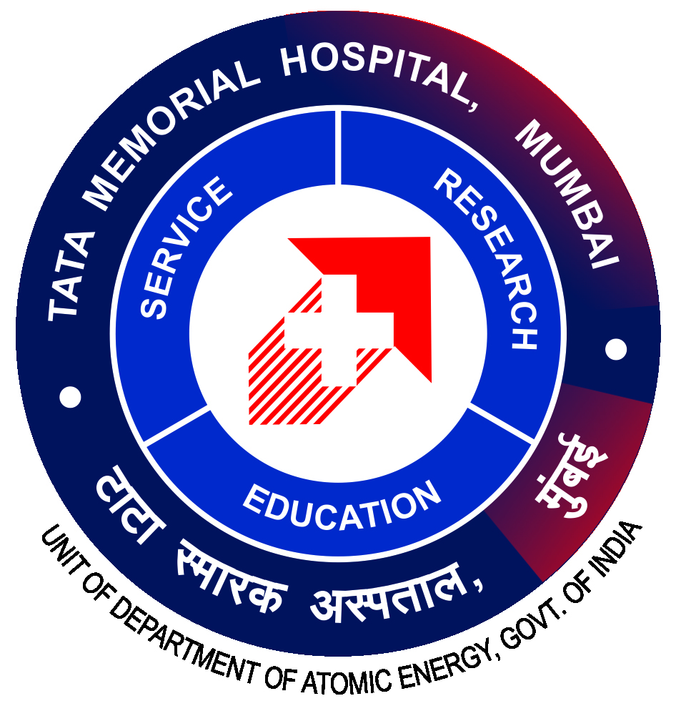

**TATA MEMORIAL CENTRE**

**A Grant-In-Aid Institute of Department of Atomic Energy, Government of India**

**(TATA MEMORIAL HOSPITAL)**

**PAREL, MUMBAI – 400 012**

**OFFICE OF DIRECTOR (ACADEMICS)**

**04.11.2024**

|  |  |
| --- | --- |
| **ADVT NO: TMC/AD/145/2024** | |
| **Last Date of Online Applications : 19.05.2025** | |
| **Name of Workshop** | **“Tobacco Control & Cessation”** |
| **Eligibility** | MBBS / MD / Medical Officers / BAMS / BHMS / PG students / Nursing Students / Dentist or Dental Students / Medical Social Workers |
| **Fees**  **(Non Refundable)** | Rs.1500/- (Rupees One Thousand Five Hundred Only) |
| **Time** | 9:00 A.M. TO 5:00 P.M. |
| **Duration** | **02 days (20.05.2025 and 21.05.2025)** |

Application forms are available at: <https://tmc.gov.in> in Training Program under Events.

Course fees are inclusive of breakfast, lunch & snacks. The amount will be credited to **Workshop on Cancer Prevention and Control Account No. 5384 (New Account Created).**

Participants can contact department of Preventive Oncology for queries.

Department Address:

Department of Preventive Oncology,

Service Block, 3rd Floor

Tata Memorial Hospital Parel Mumbai – 400012

Contact No. 022-24177000 Ext - 4670 / 4649 / 4632

**DR. S.D. BANAVALl**

**DIRECTOR (ACADEMICS), TMC**